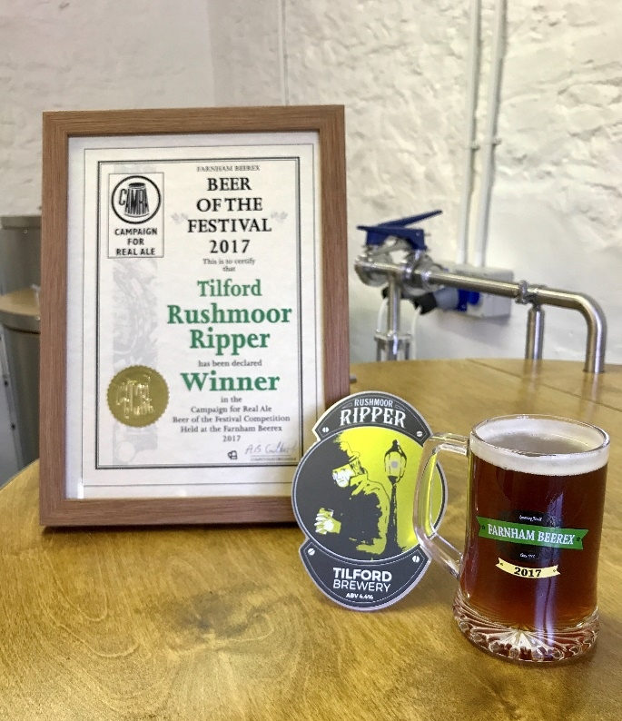
On Thursday night members of the 2017 Farnham Beerex Committee met at the Tilford Brewery, located next to the Duke of Cambridge to present brewers, Paul Griffiths and Mark Collins with the award for their Tilford Rushmoor Ripper which was voted Beer of the Festival 2017 by those attending Beerex.
Presenting the award to Mark and Paul are Andy Gilbert and Phil Alexander (Beerex Chairman).
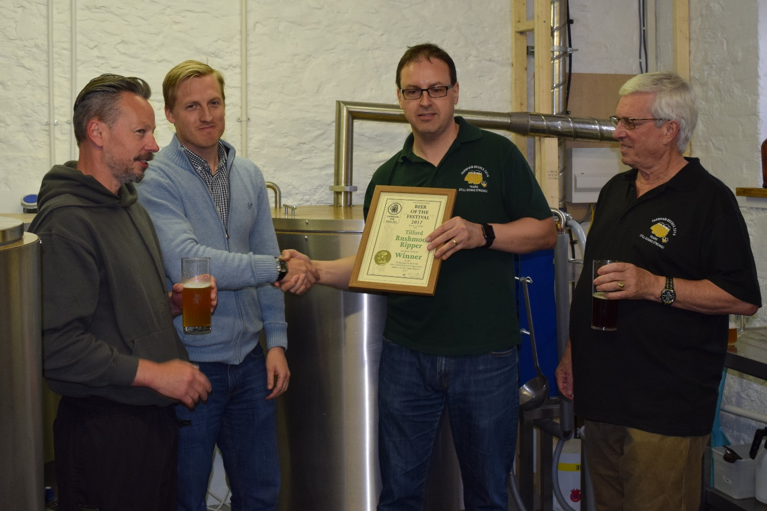
After a short break, the planning has already started for next year’s 42nd Beerex which will be on April 12th -14th

