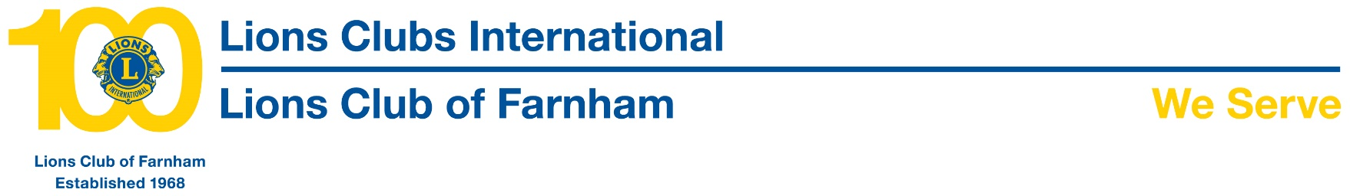
Press Release
The Lions Club of Farnham is delighted to have presented a cheque for almost £2000 to support a project undertaken by 229 (Farnham) Squadron Air Training Corp (ATC).
The squadron, which comprises young people supported by volunteer staff will use the funds, along with others already raised, to purchase a specialist computer as part of a project to build a flight simulator which they anticipate to be completed by the end of June and which will afford the cadets the opportunity to have an affordable and simulated ‘flight experience’.
This is a significant and exciting project delivered by the endeavours of members of the squadron themselves which they also hope to make available to the public at open days in the future.
The aims of the ATC are to promote and encourage among young people a practical interest in aviation and the Royal Air Force as well as provide training which will be useful in the services and civilian life and to foster the spirit of adventure and develop qualities of leadership and good citizenship.
Accepting a cheque for £1944.49 on behalf of the 229 (Farnham) Squadron from Farnham Lions President Barbara Wright is Flight Sergeant Jack Bennett watched by members of the squadron, Sean Hammond who is leading the build of the flight simulator, and Farnham Lion George Freeman.
