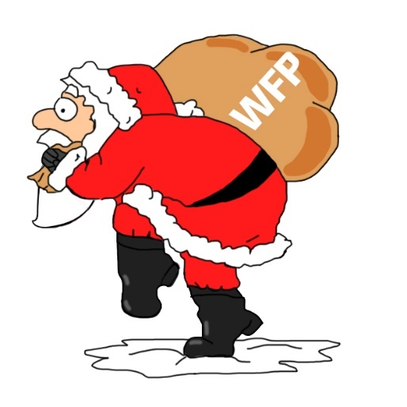

**Do you actually NEED your**

**Winter Fuel Payment?**



***To Gift Aid please see over page.***

Sponsored by

Many local people struggle to afford to stay warm and cook during the winter. We anticipate that this will be especially true again this year.

If you can, please pass on your Winter Fuel Payment or make a donation to us and we will ensure it goes directly to the fuel needy.

By working with local agencies such as Citizens Advice we can target this need. Thank you

Donate now online at: <https://www.lionsgiving.co.uk/Appeal/farnhamwenceslas>

or

by sending a cheque payable to “Farnham Lions Club”

and endorsed “WFP” on the back to:

Lion Treasurer, 1 Acheulian Close, Farnham GU9 8PL

For more info please visit: **www.farnhamlions.org.uk**

**PROJECT WENCESLAS**

**FARNHAM LIONS CLUB**



**Charity Gift Aid Declaration – single donation**

**Boost your donation by 25p of Gift Aid for every £1 you donate**

Gift Aid is reclaimed by the charity from the tax you pay for the current tax

year. Your address is needed to identify you as a current UK taxpayer.

**In order to Gift Aid your donation you must tick the box below:**

I want to Gift Aid my donation of £………………….. to:

**Name of Charity: Farnham Lions Club CIO - charity registration number 1194104.**

I am a UK taxpayer and understand that if I pay less Income Tax and / or Capital Gains Tax in the current tax year than the amount of Gift Aid claimed on all my donations it is my responsibility to pay any difference.

**My Details**

Title ………………… First name or initial(s)…………………………………………..…..

Surname ……………………………………………………………………………………………………….

Full Home Address ……………………………………………………………………………………….

………………………………………………………………………………………………………………………

Postcode ………………………………… Date …………………………………………………….

**Please notify the charity if you:**

Want to cancel this declaration

Change your name or home address

No longer pay sufficient tax on your income and / or capital gains

If you pay Income Tax at the higher or additional rate and want to receive the additional tax relief due to you, you must include all your Gift Aid donations on your Self-Assessment tax return or ask HM Revenue and Customs to adjust your tax code.