It’s Panto time!

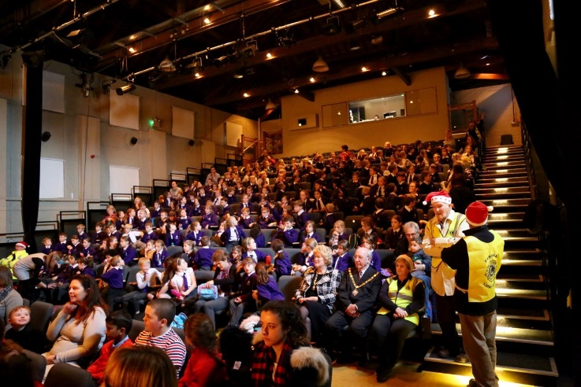
On Dec 6th members of the Lions Club of Farnham very much enjoyed welcoming 360 primary schoolchildren from William Cobbett, St Poycarps and The Ridgeway schools as well as “real life” mayor, Councillor John Ward, and the Mayoress to see “Dick Whittington” at The Maltings.
Staged by Hurricane Productions the actors put on a great show with lots of costume changes and in time-honoured fashion saw the villain being booed and hissed at and the hero cheered with gusto
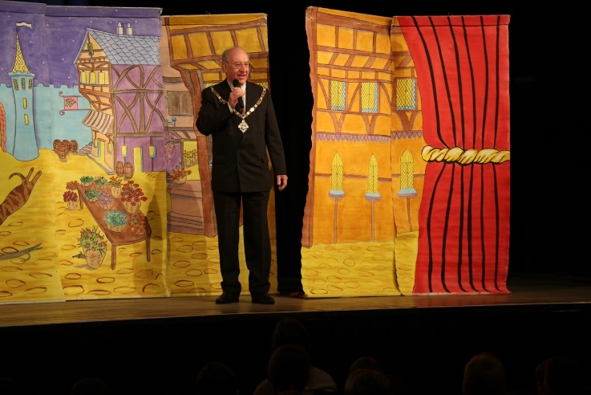
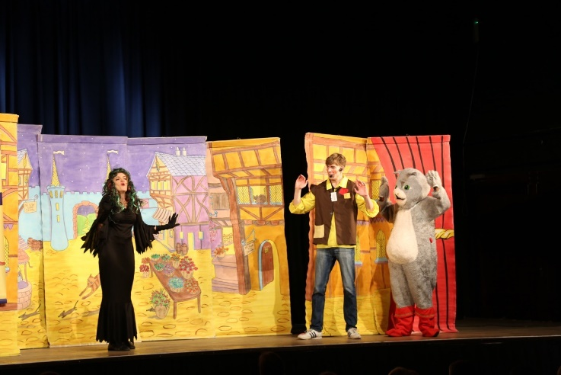
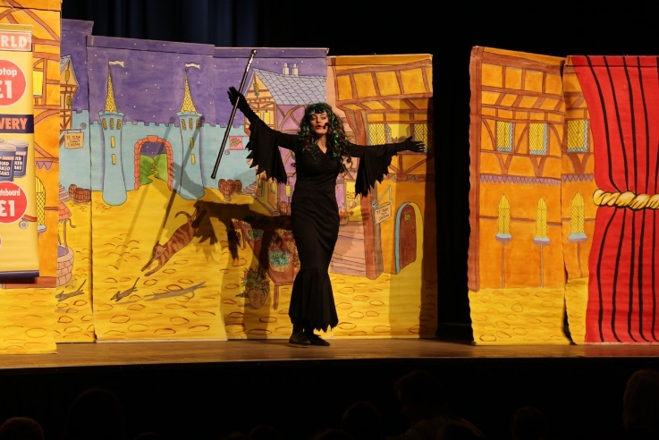
Changes made earlier this year to the Great Hall at the Maltings made the experience even better with good visibility for all the children – even the smallest!

